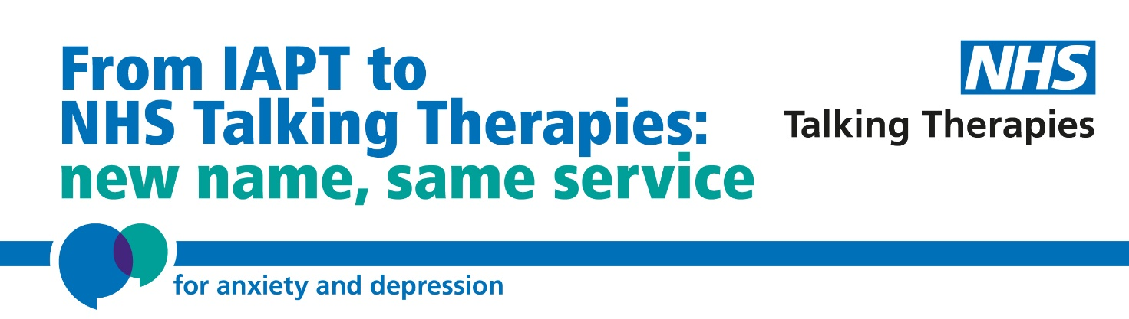
Interpersonal Psychotherapy: Supervisor Training

WEBSITE – www.annafreud.org

Introduction
Interpersonal Therapy (IPT) is one of the recognised NICE therapies for depression and as such should be one in the range of therapies offered to adults and young people. The availability of IPT and IPT-A is currently limited and inconsistent across the UK and national programmes of training are being commissioned to increase access.

Who can apply for IPT/IPT-A supervisor training?

Qualified IPT/IPT-A practitioners

- Who hold current accreditation with IPTUK and
- Who have been recommended for advanced training by their IPT/IPT-A supervisors and
- Who are supported by their service manager and clinical lead to deliver IPT/IPT-A supervision within their own service and across other services

Regional development of IPT/IPT-A relies on cross service collaboration for supervision while supervision capacity is limited, and only candidates who have managerial approval for this collaboration will be considered for training, unless this role is being undertaken in the applicant's personal time.

What training is on offer?

The training consists of three components:

- Teaching: Six teaching days delivered over 9 months.

- Advanced Practice Training: Weekly facilitated peer supervision on two IPT/IPT-A cases. Trainee supervisors will provide peer supervision, including review of recordings, in addition to receiving supervision on two cases. IPTUK supervisor accreditation requires completed casework using each of the four IPT focal areas during practitioner and supervisor training. For some therapists this may require more than six cases to be conducted to complete the training portfolio.
The deadline for completion is 6 months after training start date.

Trainees will require a minimum of 5 hours per week protected time to complete stage one requirements of supervision accreditation (approximately 20 weeks): 2 hours direct client contact, 1 hour supervision, 2 hours tape review and preparing self-assessment and peer assessment reports.

- Supervisory Practice Training: Weekly individual supervision and assessment of supervision competence when providing supervision on at least two cases with a novice IPT practitioner. This casework is conducted after completion of advance practice training.

The deadline for completion is 12 months after training start date and subject to availability
of novice trainees.

Trainees will require a minimum of 4 hours protected time per week to complete stage two requirements of supervision accreditation (approximately 20 weeks): 1 hour providing supervision, 1 hour reviewing therapy recordings, 1.5 hours preparing supervision reports and self-assessment; 0.5 hours receiving supervision.

What accreditation will successful trainees receive?
When the criteria are met, the trainee will receive:
- IPTUK Certificate of Completion for Supervisor Training in Interpersonal Psychotherapy Level D

What role will I have if I become accredited on this programme?
It is anticipated the successful trainees will continue to be employed to deliver IPT/IPT-A as a practitioner and to supervise the practice of IPT/ IPT-A within their own service and across other services as required and funded. They will continue to monitor their outcomes and complete the minimum data set.

Funding
The fee to attend five training days is £1,250
The fee for supervision of casework and supervision is £4,350
Total cost: £5,600

What to provide when applying?

- Completed application form
- Proof of current professional registration or accreditation in addition to IPTUK e.g., with BABCP, HCPC, BACP
- Confirmation of completing IPT/IPT-A practitioner training and current accreditation with IPTUK
- Copies of Practitioner Training paperwork: Session Rating Summary (Form 4), Casework Summary (Form 5), Reflective Casework summaries (RTRs or Case Reports)
- A recommendation and competency evaluation from an accredited IPT/IPT-A supervisor supporting advanced training to supervisor level
- A statement of support from line manager confirming protected time for training and supervision and access to the required IT equipment and facilities (unless training and supervision will be completed in the applicant's personal time)
- Availability to attend all training days and complete two cases of IPT/IPT-A under supervision
- Invoicing details or request for CYP IAPT funding

Applications should be submitted to: IPT@annafreud.org

The Interpersonal Psychotherapy Supervisor Course
Application Form

Please complete and return all forms no later than three weeks before the start date of the training.

Applicant Details

Name:
Address:
Telephone no
E-mail:
WTE clinical hours
Base address:
Employing organisation:
Service name:
Clinical Service Lead:
Professional registration or accreditation body and number (not IPTUK)

Why do you want to attend IPT/IPT-A Supervisor Training? (Min. 300 words)

Checklist of required documentation:

Confirmation of completing IPT/IPT-A practitioner training and current accreditation with IPTUK
Yes/No

Practitioner Training: Session Rating Summary (Form 4)
Yes/No

Practitioner Training: Casework Summary (Form 5)
Yes/No

Practitioner Training: Reflective Casework summaries (RTRs or Case Reports)
Yes/No

Recommendation and competency evaluation from an accredited IPT/IPT-A supervisor supporting advanced training to supervisor level
Yes/No

Statement of support from line manager confirming protected time and IT support
Yes/No

Availability to attend all training days and complete two cases of IPT/IPT-A under supervision
Yes/No

Invoicing details or request for CYP IAPT funding
Yes/No

Do you require any special facilities to attend the six training days? Please provide details.

Applicant: Sign: Date:

Payment details
Details required for invoice:

Name

Address

Postcode

Email

Telephone

Purchase Order Number

Reference (if required)

Please return completed application no later than three weeks before the training start date to: IPT@annafreud.org

Please also attach:
- IPTUK Practitioner accreditation/re-accreditation certificate
- Casework summary (Form 5)
- Competencies rating summary (Form 4)
- Statement of support from current line manager
- Statement of support from current supervisor, to be forwarded directly by them

